**Project Design Phase-II**

**Technology Stack (Architecture & Stack)**

|  |  |
| --- | --- |
| Date | 22 October 2022 |
| Team ID | PNT2022TMID19539 |
| Project Name | Project – IoT Based Safety Gadget for Child Safety Monitoring and Notifications. |
| Maximum Marks | 4 Marks |

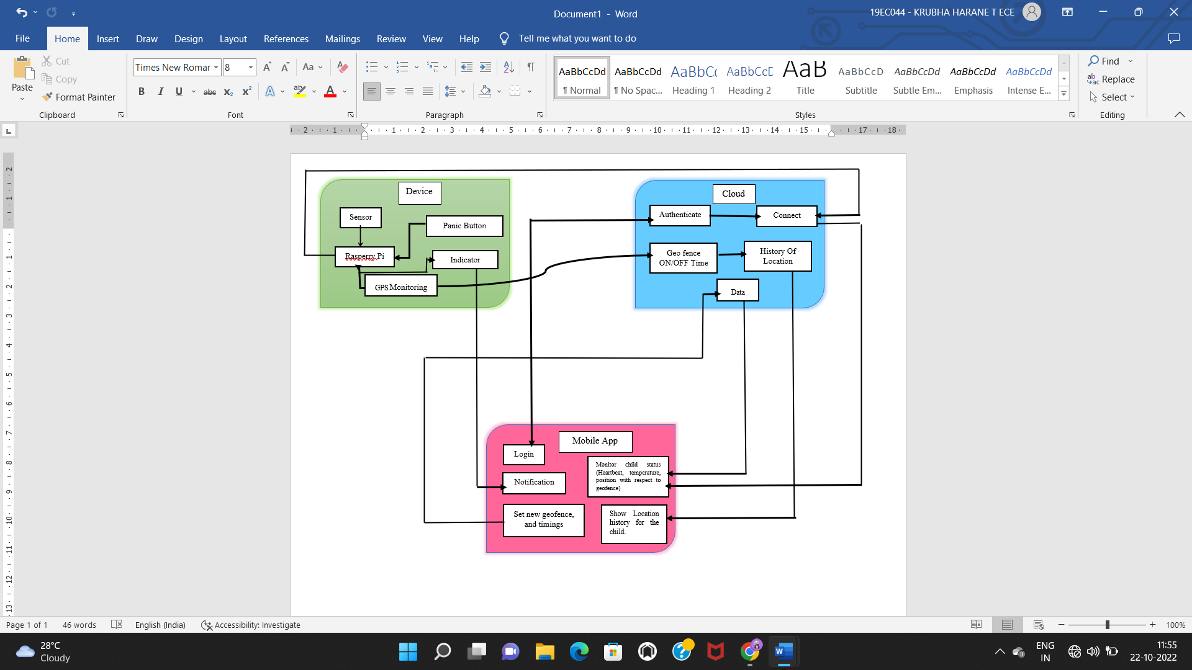

**Table-1: Components & Technologies:**

|  |  |  |  |
| --- | --- | --- | --- |
| **S.No** | **Component** | **Description** | **Technology** |
|  | User Interface | Mobile App. | MIT App Inventor |
|  | Application Logic-1 | Code development phase | Python |
|  | Application Logic-2 | Interfacing purpose | IBM Watson Assistant |
|  | Cloud Database | Database service on Cloud | IBM Cloudant |
|  | File Storage | Usage of IBM Cloud Storage. | IBM Block Storage |
|  | Browser based flow editor | Visual Programming | Node Red |
|  | Infrastructure (Server/Cloud) | Application Deployment on Local Server | Cloud Platform |

**Table-2: Application Characteristics:**

| **S.No** | **Characteristics** | **Description** | **Technology** |
| --- | --- | --- | --- |
|  | Open-Source Frameworks | A template for software development that is designed by social network. | IBM Watson Platform, Node Red. |
|  | Security Implementations | Login and authentication protect from unauthorised entries from accessing cloud data. | IBM Cloud. |
|  | Scalable Architecture | Presentation Tier (Mobile App): Mobile App will act as an interface between the parent and the device.  Logic Tier (Rasperry Pi): It will get the data from the sensor and the GPS and it will send it to the cloud.  Data Tier (Cloud) : It will store the data and send it to the mobile app. | Mobile App, Rasperry Pi, IBM Cloud. |
|  | Availability | Always connected to cloud. | IBM Cloud. |
|  | Performance | Able to send the location of the child time to time and the sensors will send the biometrics of the child in the app. | Rasperry Pi, Mobile App. |